Module 5: Factors, Divisibility and Mathematical Loops
Question 3: Factorial!
Platform: HackerEarth
Difficulty: Easy
Problem Link: https://www.hackerearth.com/practice/basic-programming/input-output/basics-of-input-output/practice-problems/algorithm/factorial/
Problem Statement
You have been given a positive integer N. You need to find and print the factorial of this number.
The factorial of a positive integer N is the product of all numbers in the range from 1 to N.
Input Format
The first and only line of the input contains a single integer N.
Output Format
Output a single line denoting the factorial of N.
Example
Input:
2
Output:
2
Code Screenshot
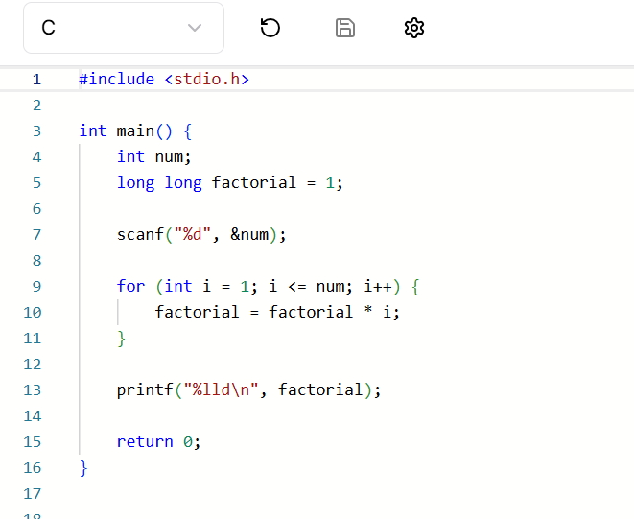

Output Screenshot
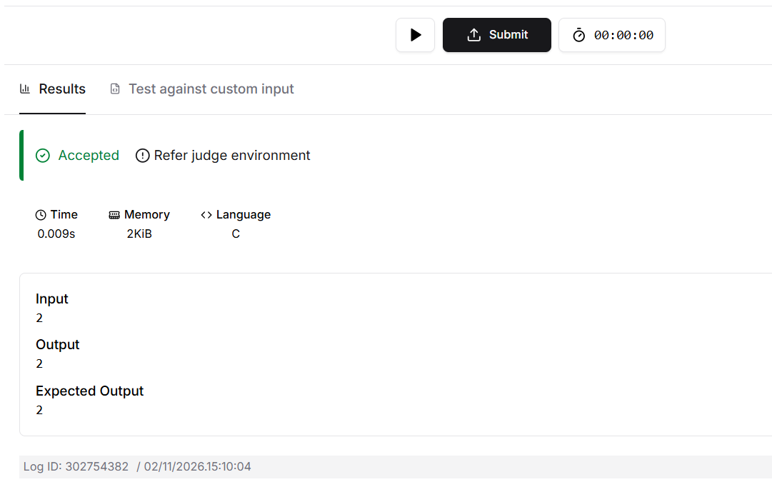
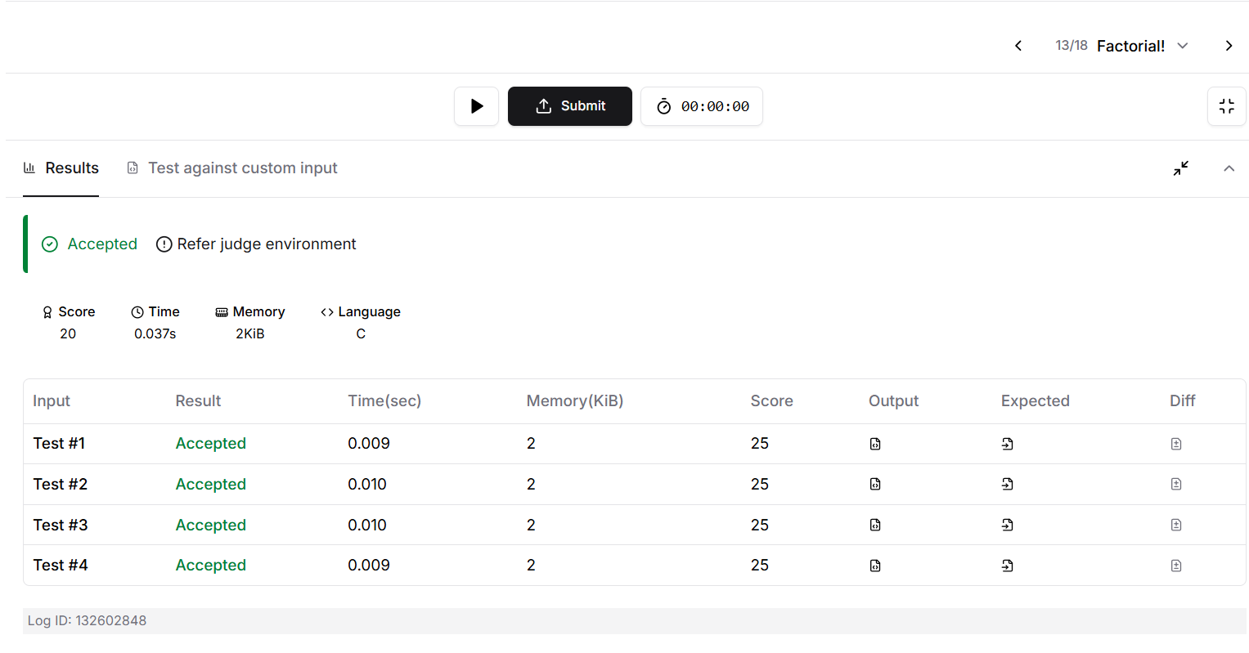Result
The program calculates and prints the factorial of the given number. Platform: HackerEarth.

